[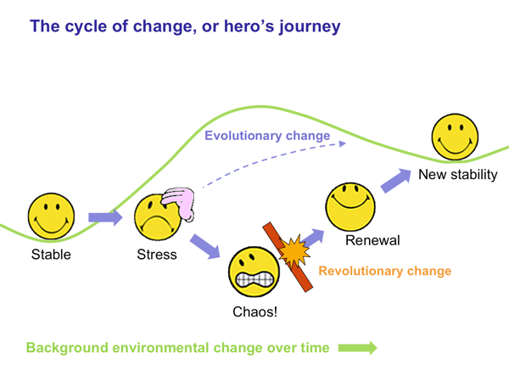](http://www.google.co.uk/url?sa=i&rct=j&q=&esrc=s&source=images&cd=&cad=rja&uact=8&ved=0ahUKEwisuczPhpbOAhXDQJoKHd4zDboQjRwIBw&url=http%3A%2F%2Fwww.eman8.net%2Fchange%2Fthe-dynamics-of-change%2F&psig=AFQjCNEf4WS8ta1IC4YLJLRCz72fo-OY9A&ust=1469791489872465)

[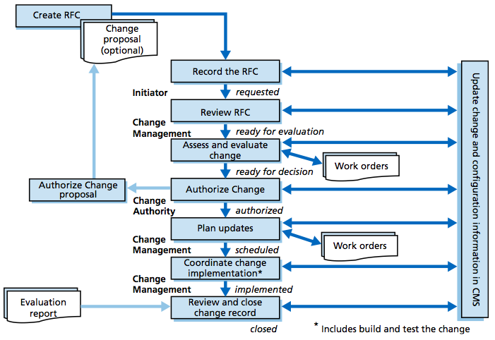](http://www.google.co.uk/url?sa=i&rct=j&q=&esrc=s&source=images&cd=&cad=rja&uact=8&ved=0ahUKEwiM89z1hpbOAhWEDpoKHfzDAhIQjRwIBw&url=http%3A%2F%2Fdocplayer.net%2F5699682-Implementing-itil-change-management.html&psig=AFQjCNEf4WS8ta1IC4YLJLRCz72fo-OY9A&ust=1469791489872465)

[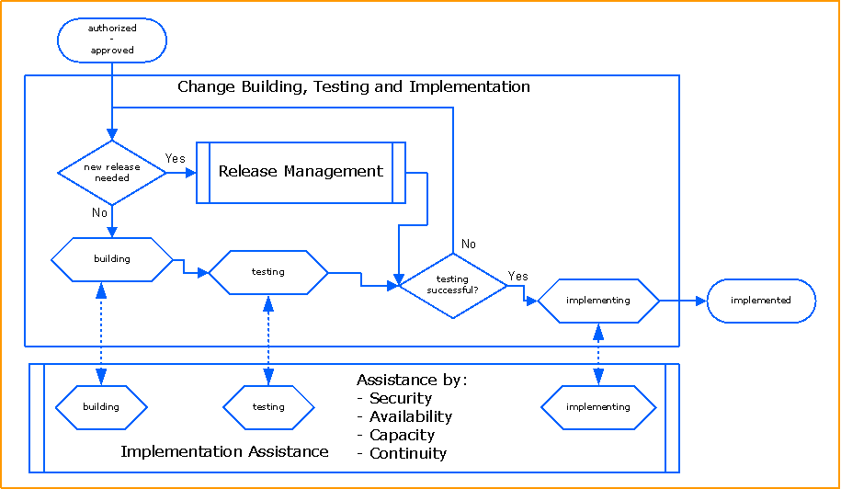](https://www.google.co.uk/url?sa=i&rct=j&q=&esrc=s&source=images&cd=&cad=rja&uact=8&ved=0ahUKEwjXneKDh5bOAhViIpoKHRdfDKsQjRwIBw&url=https%3A%2F%2Fwww.mitsm.de%2Fchange-management-en&psig=AFQjCNEf4WS8ta1IC4YLJLRCz72fo-OY9A&ust=1469791489872465)

[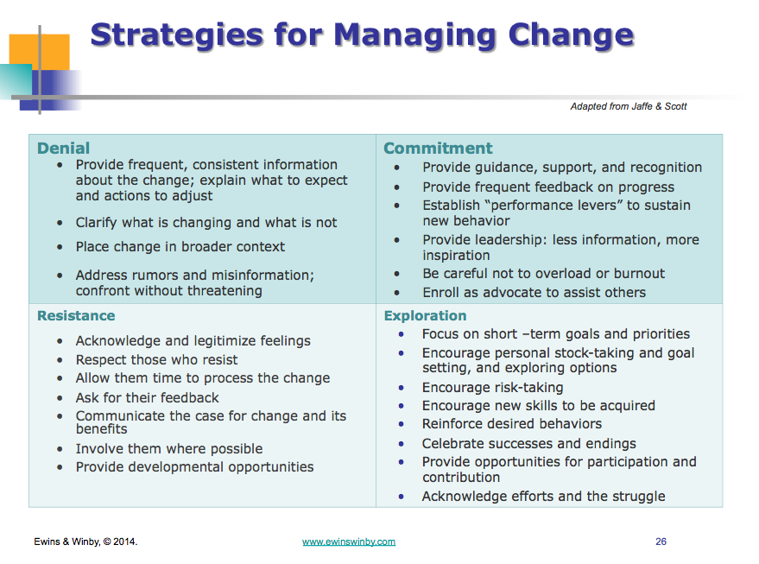](http://www.google.co.uk/url?sa=i&rct=j&q=&esrc=s&source=images&cd=&cad=rja&uact=8&ved=0ahUKEwiVoYifh5bOAhXmK5oKHe2HC_0QjRwIBw&url=http%3A%2F%2Fwww.i4process.com%2F3140%2Forganizational-change-management-start-part-2%2F&psig=AFQjCNEf4WS8ta1IC4YLJLRCz72fo-OY9A&ust=1469791489872465)

[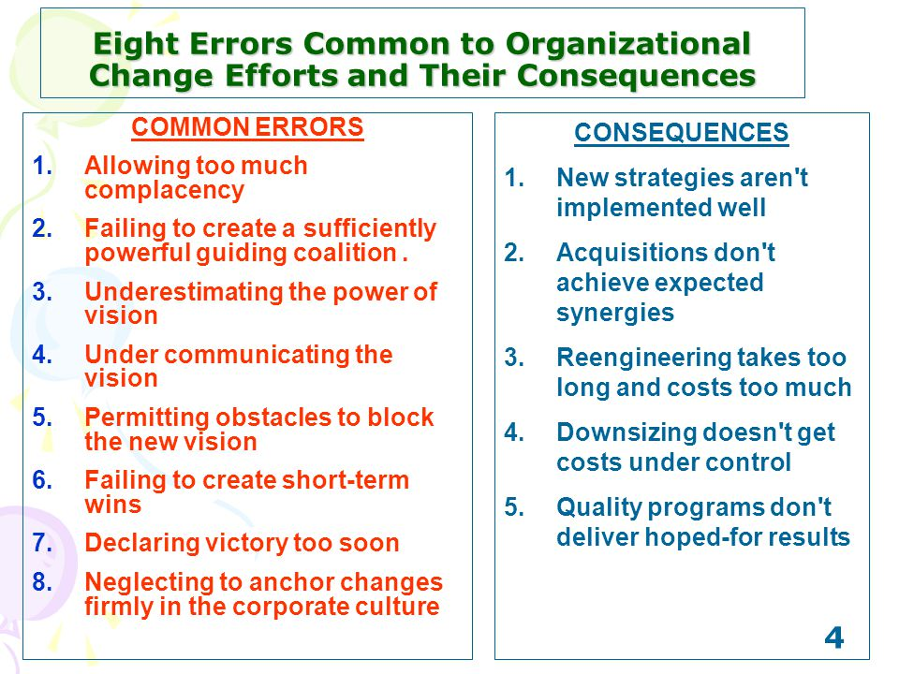](http://www.google.co.uk/url?sa=i&rct=j&q=&esrc=s&source=images&cd=&cad=rja&uact=8&ved=0ahUKEwi1s7yqh5bOAhVlMJoKHcWsAPwQjRwIBw&url=http%3A%2F%2Fslideplayer.com%2Fslide%2F1515870%2F&psig=AFQjCNEf4WS8ta1IC4YLJLRCz72fo-OY9A&ust=1469791489872465)

[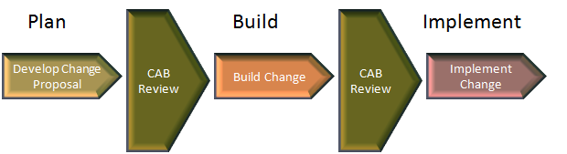](http://www.google.co.uk/url?sa=i&rct=j&q=&esrc=s&source=images&cd=&cad=rja&uact=8&ved=0ahUKEwiVnt7oiJbOAhVIOJoKHQfnATsQjRwIBw&url=http%3A%2F%2Fitsmtransition.com%2F2013%2F04%2Fmature-basic-itil-change-management%2F&psig=AFQjCNEf4WS8ta1IC4YLJLRCz72fo-OY9A&ust=1469791489872465)

[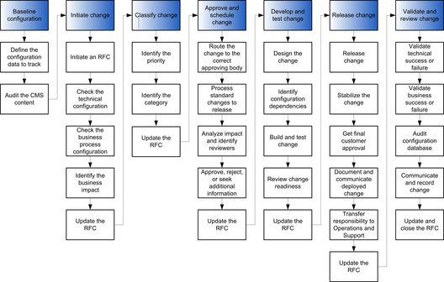](https://technet.microsoft.com/en-us/library/cc543208.aspx)

[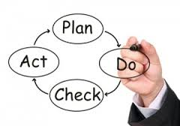](https://www.google.co.uk/imgres?imgurl=http%3A%2F%2Fwww.gfi.com%2Fblog%2Fwp-content%2Fuploads%2F2010%2F05%2FChange-Management-300x211.jpg&imgrefurl=http%3A%2F%2Fwww.gfi.com%2Fblog%2Fimportance-itil-change-management-proces%2F&docid=8Y88gYcMPT92PM&tbnid=k7mFF9ElWxqdkM%3A&w=300&h=211&bih=908&biw=1280&ved=0ahUKEwjEoaOOhpbOAhVFDJoKHdjkBUgQMwh2KDkwOQ&iact=mrc&uact=8)